MARS
Management of Awards to Recipients
MWA User Manual
Table of Contents
System Requirements 3
Operating System 3
Internet Connection 3
Web Browser 3
Other Required Technical Specifications 3
MARS Security Levels 4
Registering in MARS 5
Logging Into MARS 6
Controlling Access 7
What to Do If You Forgot Your Password 9
Main Menu 11
Updating User Information and Password 12
Page Help 13
Requesting Cash 14
Certifying Cash Requests 15
Reporting Expenditures 16
Certifying Expenditures 18
Revising Certified Expenditure Reports 18
Revising Closeout Reports 18
Viewing Data 19
Draws Payment Ledger 20
Draws 21
Expenditure Report Summary 21
Grant Action Notice (GAN) 22
Grant Budget List 23
Projects 25
Recipient Identification 26
Users/Security Level 26
For Assistance with MARS 27

System Requirements
The MARS Financial Reporting System was designed to allow computer users to access the system with little or no change to their normal computer environment. The four requirements that are mentioned below are common computer elements that are generally present on most computers.

Operating System
The MARS Financial Reporting System was designed for the most common operating systems; Windows, and Macintosh. Users accessing the system from a Macintosh environment are required to have MacOS 7.5 or higher running on a PowerPC processor. Windows users are required to have an operating system that is Windows 95 or higher. MARS was not tested, and therefore not supported on operating systems such as Linux, and UNIX.

Internet Connection
The MARS Financial Reporting System is a web-based application. It is accessed through the internet and was specifically created for internet usage. To use the MARS Financial Reporting System, at minimum, you must have access to an internet connection through a modem. If using a dial-up connection over a modem, the connection speed should be at least 33.6 kbps. DSL and Cable connections will improve the speed at which the system operates, but are not necessary to use the system.

Web Browser
MARS was designed to be compatible with multiple web browsers including the following:
Microsoft Internet Explorer 6.0 or higher
Firefox 2 or higher
Netscape Navigator 6.0 or higher

Other Required Technical Specifications
The following are required for optimal system use:
- The computer screen resolution should be set to 800x600 or higher to view the MARS system.
- Any pop-up blockers should be turned off prior to logging on to the system for the best performance.
- You must have a user name and password for the MARS system, as well as a valid email address.

MARS Security Levels
MARS has three security levels for MWA users; MWA Authorized Official, MWA Data Entry, and MWA Viewer.
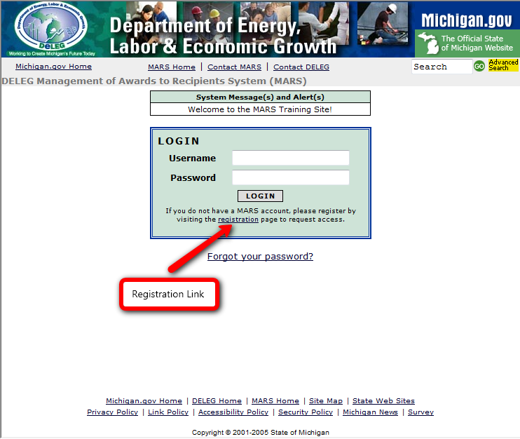
MWA Authorized Official is the highest security level available for MWAs. A MWA Authorized Official has the ability to fill out and certify expenditure reports, and cash requests. They can access report information to manage grants. MWA Authorized Officials can control access for MWA Data Entry and MWA viewer’s security levels. The MWA Authorized Official is the only security level that requires approval by the Agency/Dept. Administering MARS. Once the MWA Authorized Official registers in MARS, the MARS system administrator in the Agency/Dept. Administering MARS will be notified and will establish and approve the security.
MWA Data Entry security level for MWAs enables users to fill out expenditure reports and cash requests. They can access report information to manage grants, and can control access for MWA viewer’s security level. MWA Data Entry users cannot certify expenditure reports and cash requests.
MWA Viewer security level for MWAs allows users to access report information to manage grants. This security could be also given to auditors.

Registering in MARS
To access the MARS Financial Reporting System type http://www.michigan.deleg-mars.org/ into the address bar of your web browser and hit the enter button on your keyboard. The page that you see on your web browser should look like the image shown above:
Registering in MARS:
- In the log-in box on the MARS home page click the “registration” link
- Enter the information in all required fields.
- The “Password” must be between 8 and 12 characters and at least one character must be a number.
- Note: Fields not required to be filled out are; Middle, Phone Ext., and Fax Ext.
- Click the “Register” button at the bottom of the page

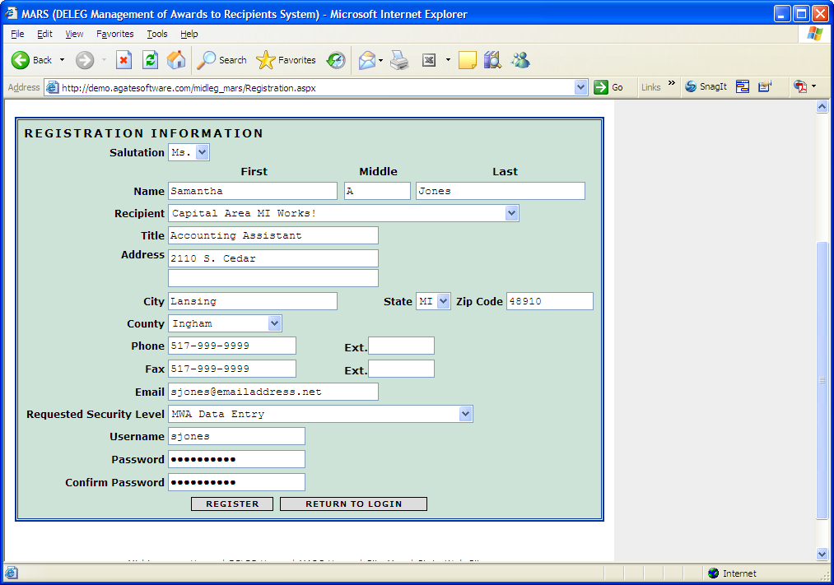

4. If the person registering is the first and only MWA Authorized Official for the MWA, then DELEG will activate and assign security. DELEG will be notified via an automatic email.
5. If the MWA has an active MWA Authorized Official, that person can activate and assign the security for all other MWA MARS users. The MWA Data Entry security can also grant access to the lower security of MWA Viewer. See the “Controlling Access” section.
6. Once security has been activated and assigned by DELEG or the MWA Authorized Official, the user will receive an email notification and will then be able to login to the system.

Logging Into MARS
To login to MARS you must have a username and password. Enter the username and password that was created during the registration process and click the “login” button.
Login errors can occur for several reasons: username was entered incorrectly, password was entered incorrectly, or security has not yet been activated. Make sure the username and password (the password is case-sensitive) have been entered correctly. If you know that your security has been activated and used, try having your password emailed to you (see section What to Do If You Forgot Your Password).
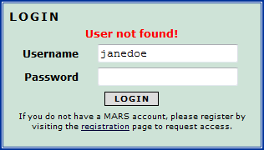

Controlling Access
A MWA Authorized Official and MWA Data Entry security levels have the ability to give access to other users below their security level. To add a user to MARS:
- The MWA Authorized Official or MWA Data Entry user must first login to the system.
- In the box labeled “What would you like to do?” click on the “Control Access” link.

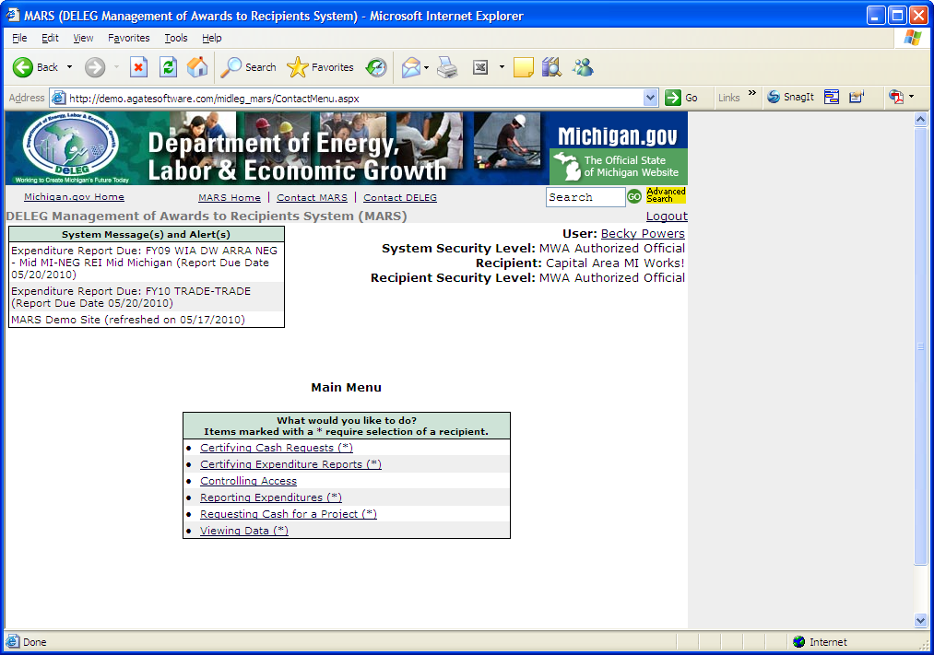

- Search for users in the box labeled “Search”
- Enter the user’s username or enter their name in the fields provided
- Click search

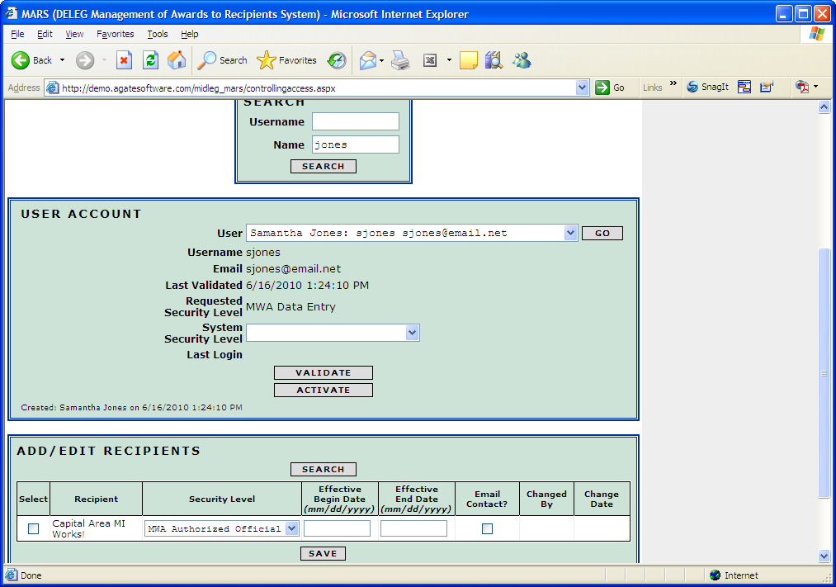

- The user’s information will populate in the “User Account” box.
- Check the “Requested Security Level”.
- Select the proper System Security Level from the drop-down (this may be different then the level requested).
- Click on the “Validate” button in the “User Account” box.
- Press the “Activate” button to Activate. The title of the button then changes to “Deactivate”. That button is used to deactivate the person’s security should they leave employment or simply does not need the security anymore (e.g. auditors).
- In the box at the bottom of the page press the search button if the appropriate recipient is not displayed.
- Select the box to assign the user security to the appropriate recipient
- Effective begin and end date restricts a user from accessing MARS before or after the dates entered. To add an effective begin and end date to a user’s profile, click on the “Search” button in the “Add/Edit Recipients” box. Enter the dates into the “Effective Beginning Date” and the “Effective End Date” field, and click on the “Save” button.
- If the user should receive MARS e-mail notifications on GANS and processed cash requests, check the box under “E-mail Contact?”

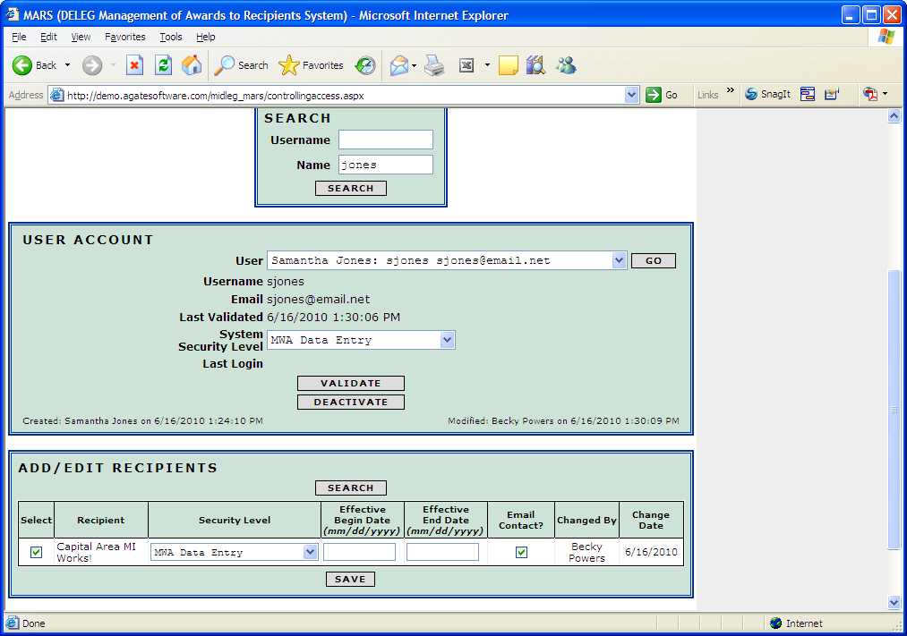

Note: An Effective Begin Date or an Effective End Date was not entered or required. Also note that the security level in the bottom box was changed to “MWA Data Entry” prior to saving.

What to Do If You Forgot Your Password
If you forget your password, click the “Forgot your password?” link below the login box. Enter your username and the same email address that is currently saved in MARS.
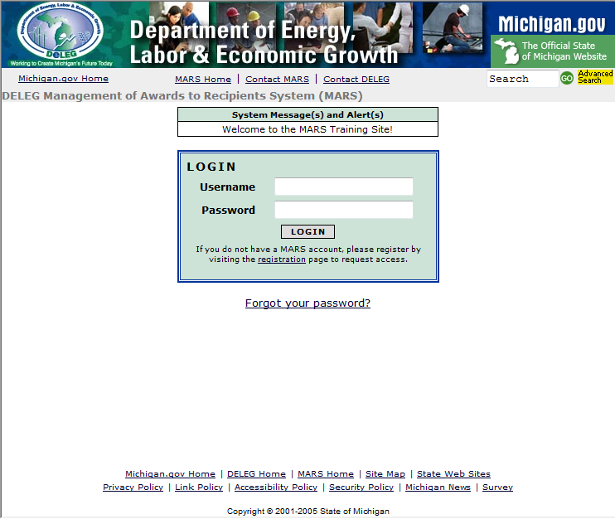
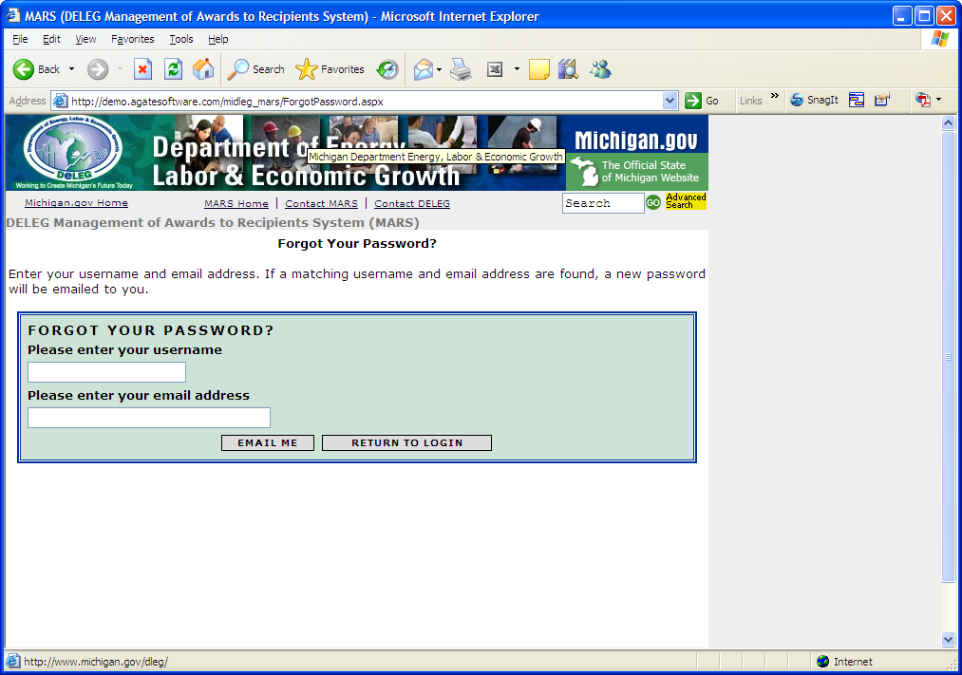
Click on the “Email Me” button and an email will be sent to you with a new password that the system has created. The first time you use the system created password you will be asked to create a new password. Select a password that is easy to remember and meets the password requirements (see requirements in “Registering In MARS”).

Main Menu
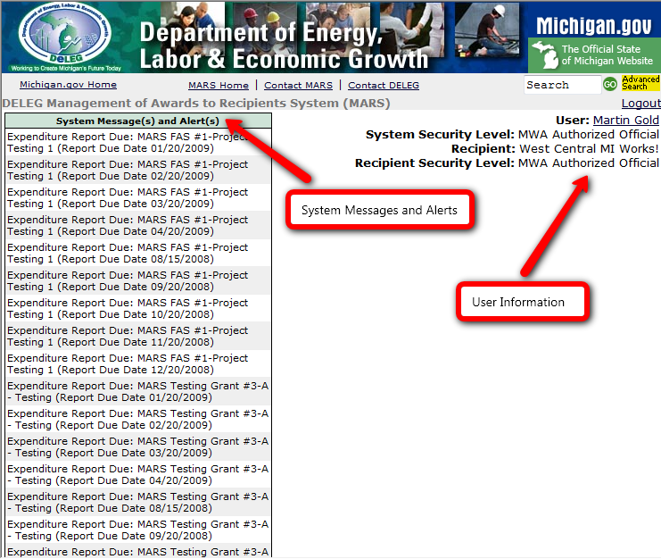
The column to the left houses all of the system messages and alerts such as expenditure report due dates. The upper right hand corner displays the user’s information such as, user, system security level, recipient, and recipient security level.

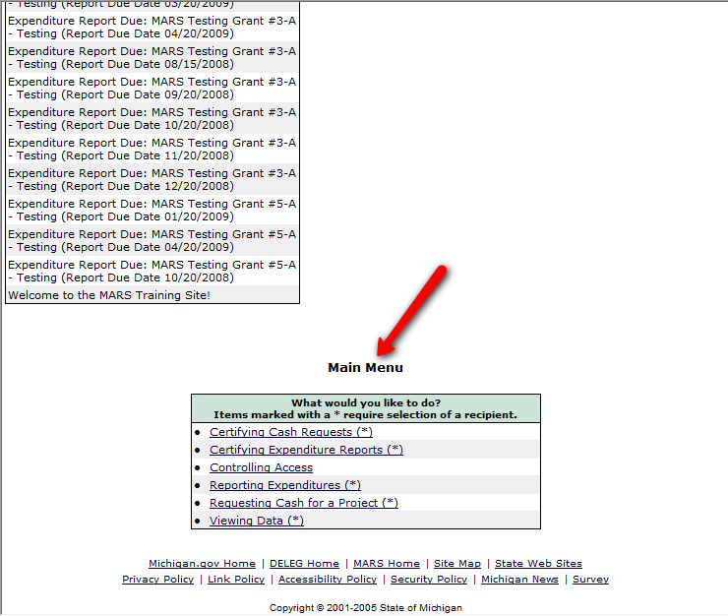
At the bottom of the page is the Main Menu. The links located under “What would you like to do?” vary based on the user’s security level.

Updating User Information and Password
After logging in, click on your user’s name in the upper right corner of the screen. Update or add information in the fields provided. Click the “Save” button once all the information has been updated.

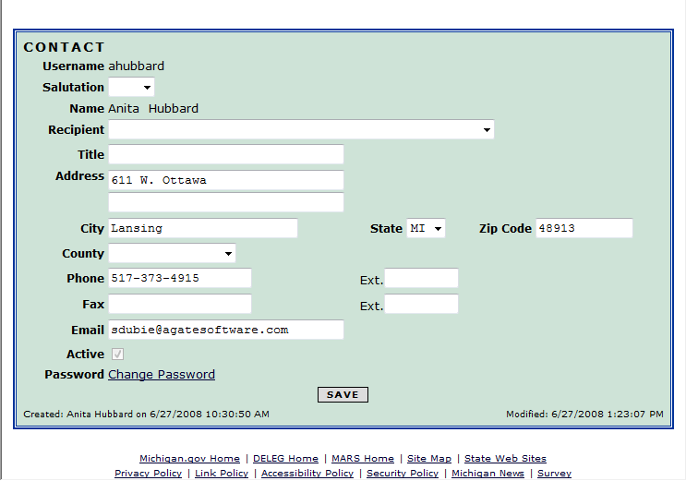
Press “Change Password” to change your password. Enter your old password then your new password in the fields provided, then press “Save”.
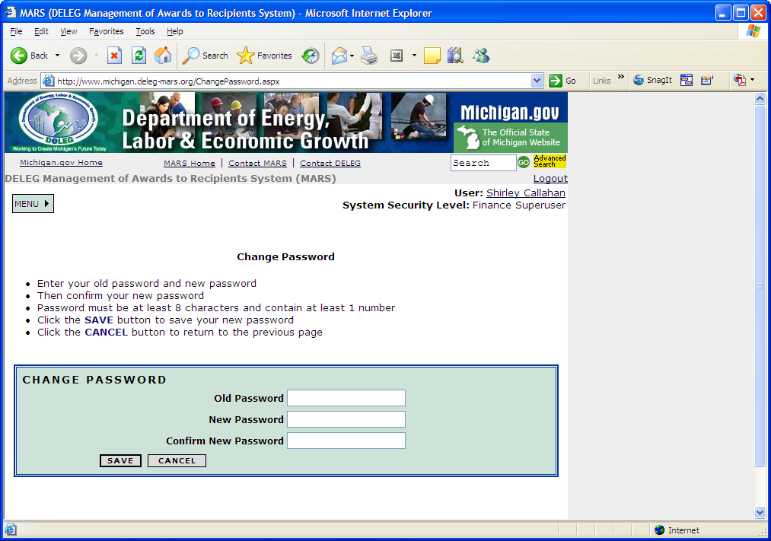

Page Help
On most pages in MARS, there are “Show Help” buttons. Once the button is clicked a box will display on the page with instructions on how to complete that function. To hide the instructions again click on the “Hide Help” button.

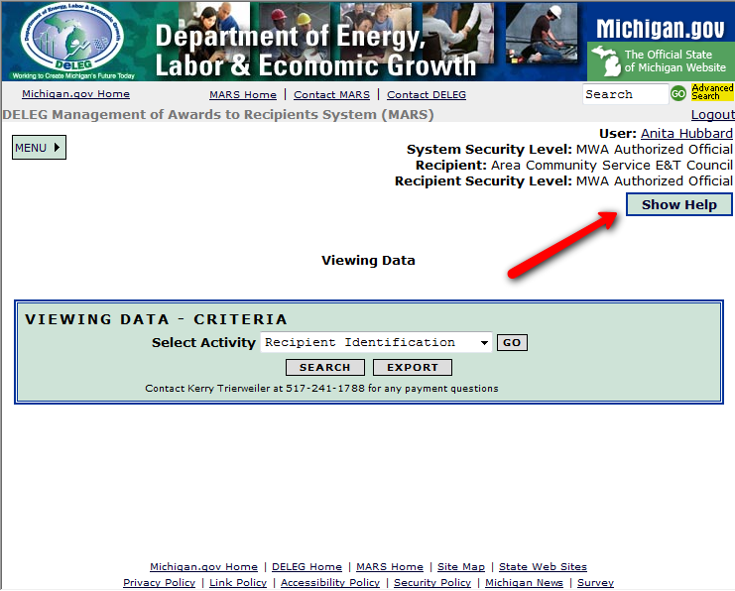

Requesting Cash
Click on the link under the “Main Menu” called “Requesting Cash for a Project”. Next, click on the “Select” link in the left hand column next to the project that you are requesting cash for.
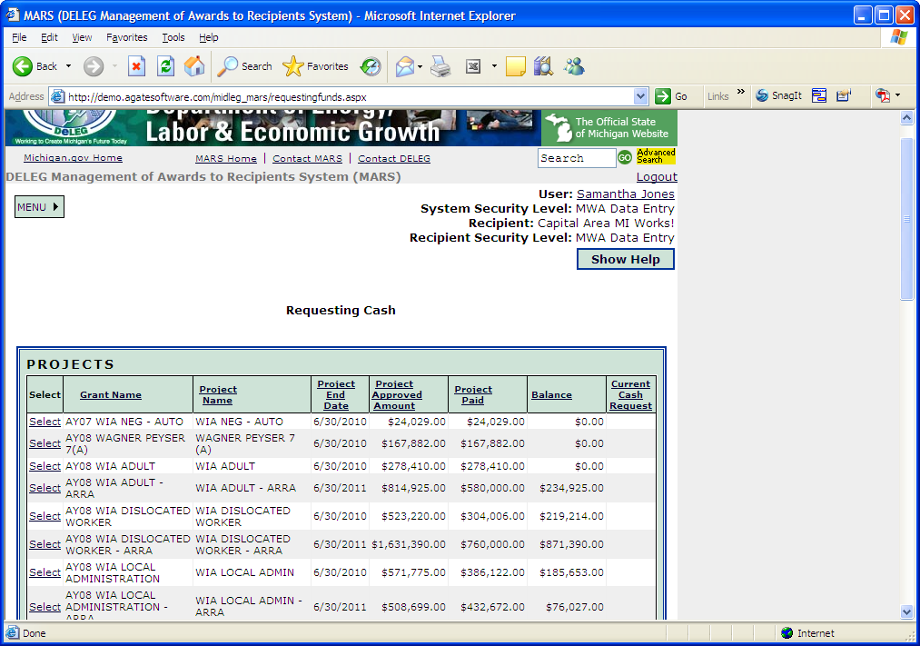
Type the amount of cash you are requesting in the field labeled “Amount”. Click the “Save” button.
Note: If you are transferring money to another project, enter a negative number in the field labeled “Amount”. Your total net cash request must be greater than or equal to $1

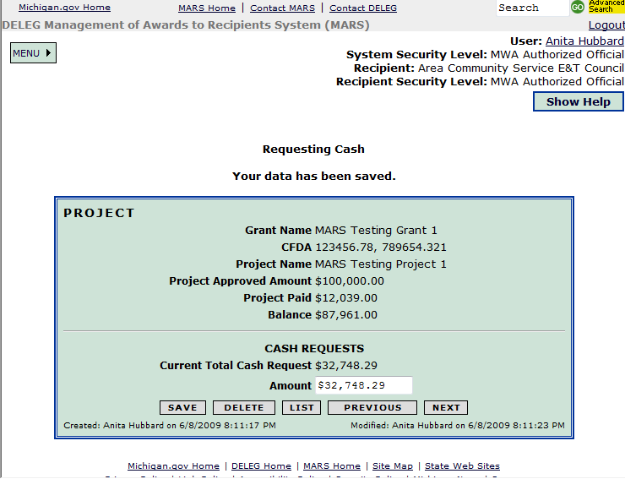

Certifying Cash Requests
To certify cash requests the user must have a MWA Authorized Official security level. Click on the link under “Main Menu” called “Certifying Cash Requests”.
At this point, if you need to edit the cash request, click the “Edit” link to the left of the grant name.
If all of the amounts that are shown on the screen are correct, click the “I Certify” button.
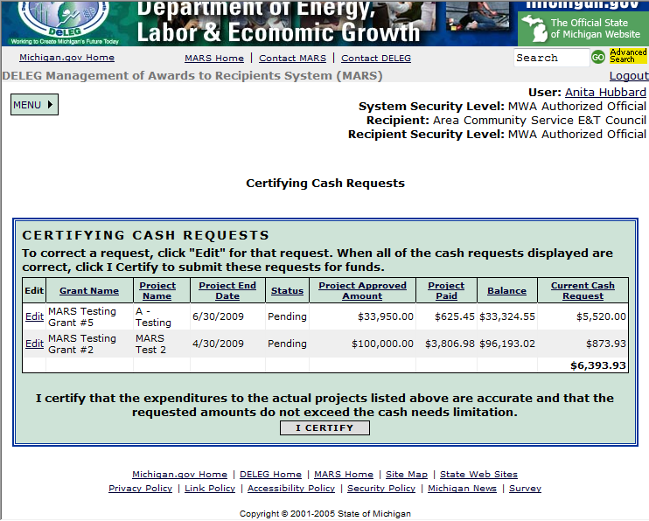

Reporting Expenditures
The user must have a security level of MWA Authorized Official or MWA Data Entry to access “Reporting Expenditures”. Under “Main Menu” click on the link “Reporting Expenditures”. Only reports that pertain to the current reporting period will populate in the list. Locate the grant/project and proper reporting period and click “Select” in the left column.
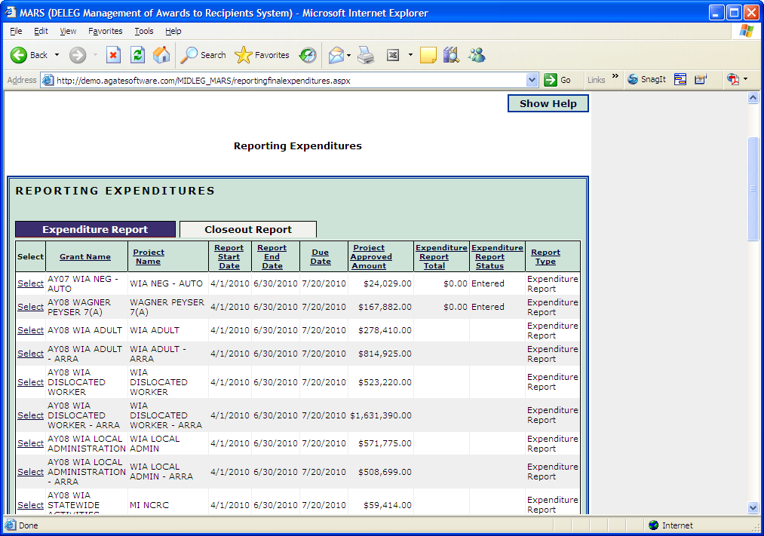

Please note that the four fields related to personal identification are open for additional information; these fields are not currently used and can be ignored.
Based on the grant that you are reporting on, the reporting tabs will vary. Each section must be filled out completely (NOTE: if you do not have an expense enter a zero in the field, otherwise the system will mark the field as incomplete). REMEMBER: You must click the “Save” button at the bottom of each of the completed forms before moving on to the next tab.
Review the report to confirm that all of the information you have entered is complete. If all information is complete, click the “Post” button at the bottom of the page.
The “Restart” button at the bottom of the page will clear out all information that has been entered for the expenditure report.
The “List” button will return the user to the list of expenditure and closeout reports that need to be completed.
The “Previous” and “Next” buttons change the tab that the user is currently on.
Closeout reports are completed under “Reporting Expenditures” but under the “CLOSEOUT” tab (see above). Follow the same process as the expenditure reports.

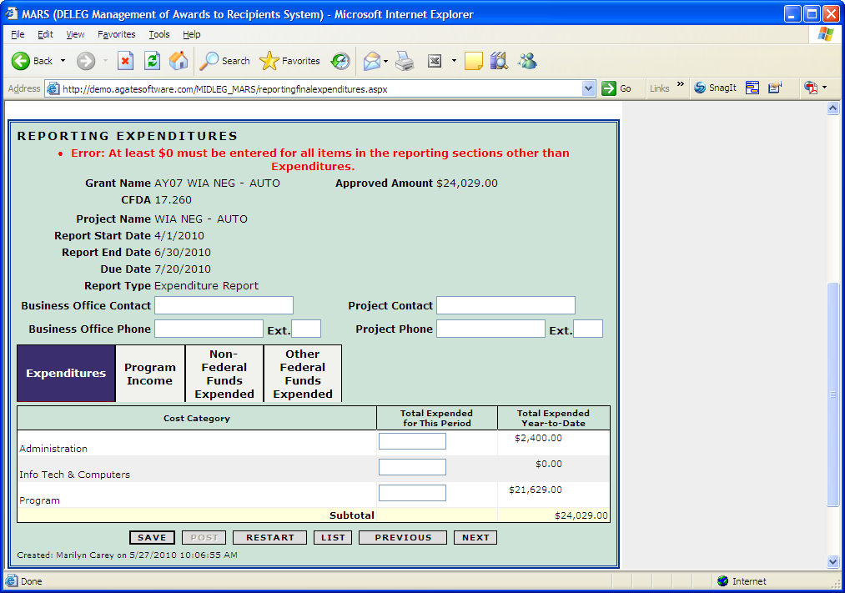

Certifying Expenditures
Only the MWA Authorized Official security level can certify expenditure reports. Under “Main Menu” click on the link “Certifying Reporting Expenditures”. A list will populate will all of the reports that have been “posted”. Select the report that you want to review and certify. After reviewing the report, if it is accurate, click the “I Certify” button at the bottom of the page.
NOTE: If the report needs to be corrected, the changes must be made by a MWA Data Entry user or a MWA Authorized Official User. Once the report has been corrected, it must be “posted” again.

Revising Certified Expenditure Reports
Once a report is certified it is sent through a batch process overnight and no longer allowed to be changed. If the report needs to be corrected please contact the Dept./Agency administering the MARS System.

Revising Closeout Reports
Once a report is certified it is sent through a batch process overnight and no longer allowed to be changed. If the report needs to be corrected please contact the Dept./Agency administering the MARS System.

Viewing Data
Viewing Data functionality is queries and/or reports that can be exported into EXCEL. Click on the “Viewing Data” link under Main Menu. After clicking the link the screen should look like this:
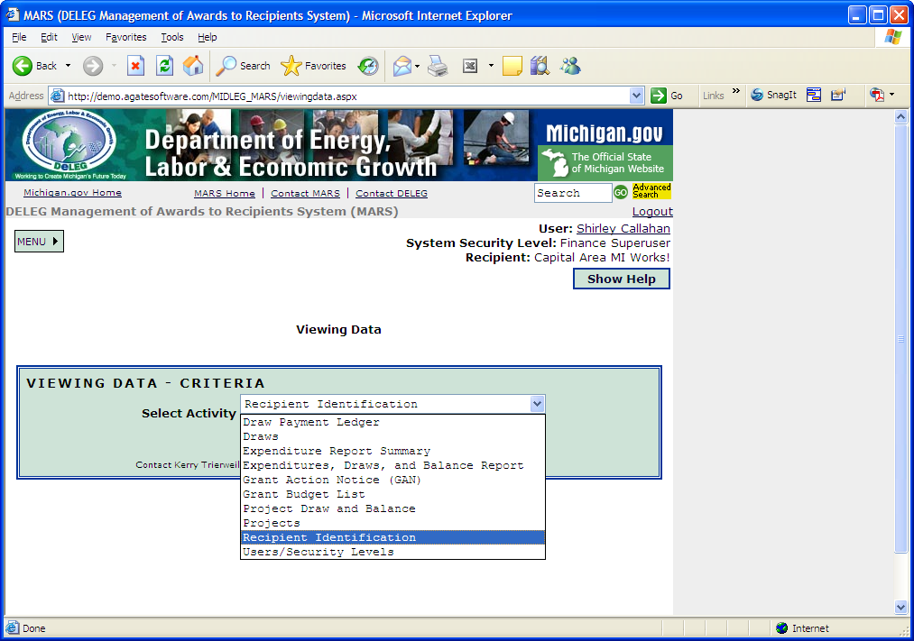
In the drop down box there are ten reports or queries:
Draw Payment Ledger
Draws
Expenditure Report Summary
Expenditures, Draws, and Balance Report
Grant Action Notice (GAN)
Grant Budget List
Project Draw and Balance
Projects
Recipient Identification
Users/Security Levels

Draws Payment Ledger

This report will bring up all the payment documents related to draws. If you select a payment document it will take you to the details showing how much funds was drawn for each project.
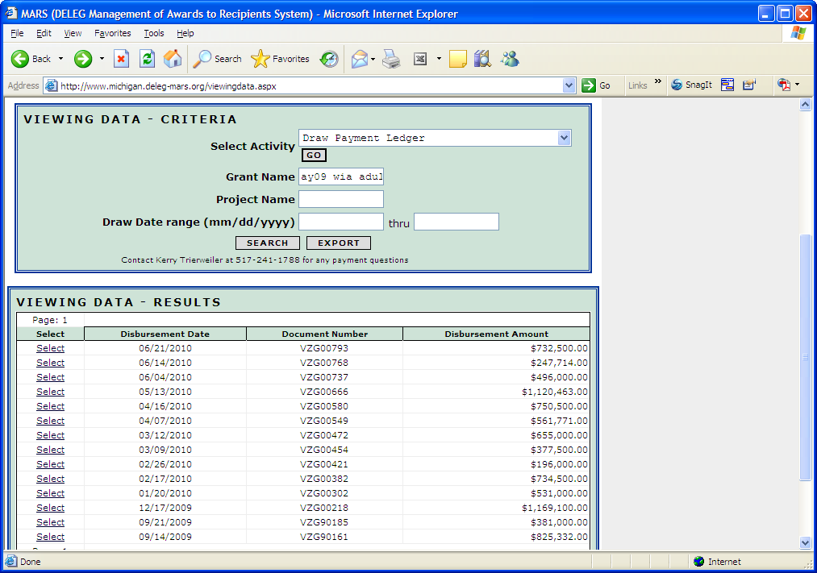
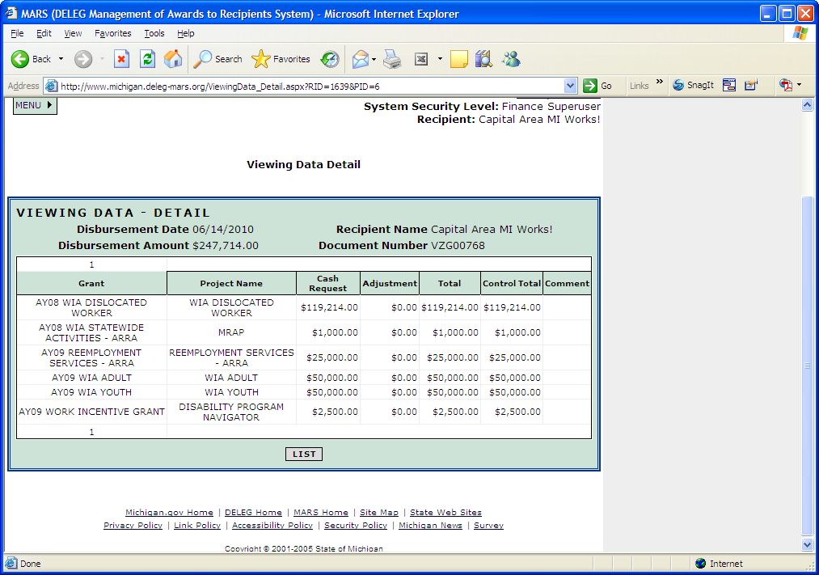

Draws
The Draws report includes information such as the grant name, project name, cash request amount, total, date, and the user that requested the draw.
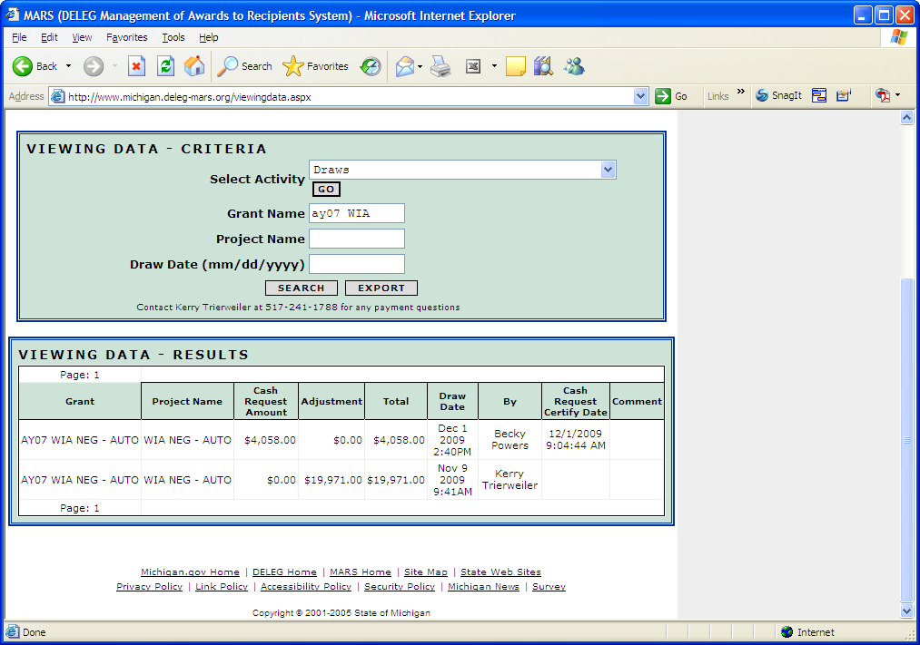

Expenditure Report Summary
The Expenditure Report Summary includes all the information that was entered on the Expenditures Reports to include: recipient name, grant name, project name, reporting period, (report) version, Status, Certified By, Date Certified, amounts reported in each cost category, report total, award amount, transfers (WIA Adult and Dislocated Worker), net budget, and the current cumulative total. If you click on “Select” by any of the listed reports you will be taken to the actual screen for the report that was entered for viewing only.

Expenditure, Draws, and Balance Report
The Expenditure Report Summary includes Grant, Project, Project End Date, Award, Cumulative Draws, Balance Approved – Cumulative (Award less Cumulative Draws), Expended, and Unspent Balance (Award less Expended).

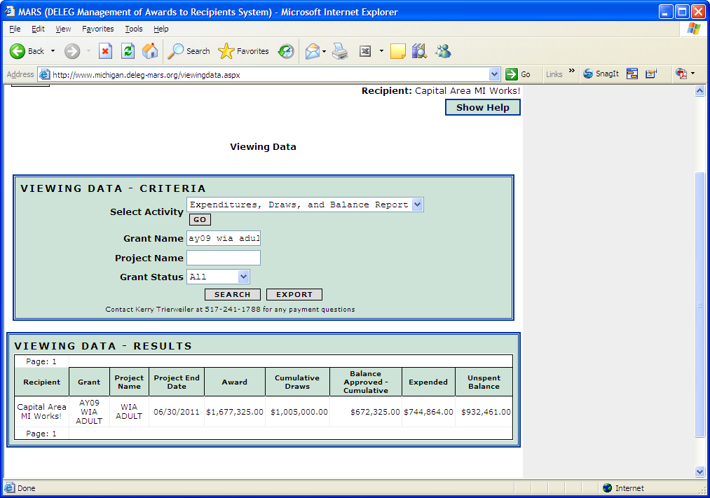

Grant Action Notice (GAN)
This query will bring up the information for Grant Action Notices and the link to view and print the printable GAN

Grant Budget List
This query will show all the awards by project and grant and net transfers

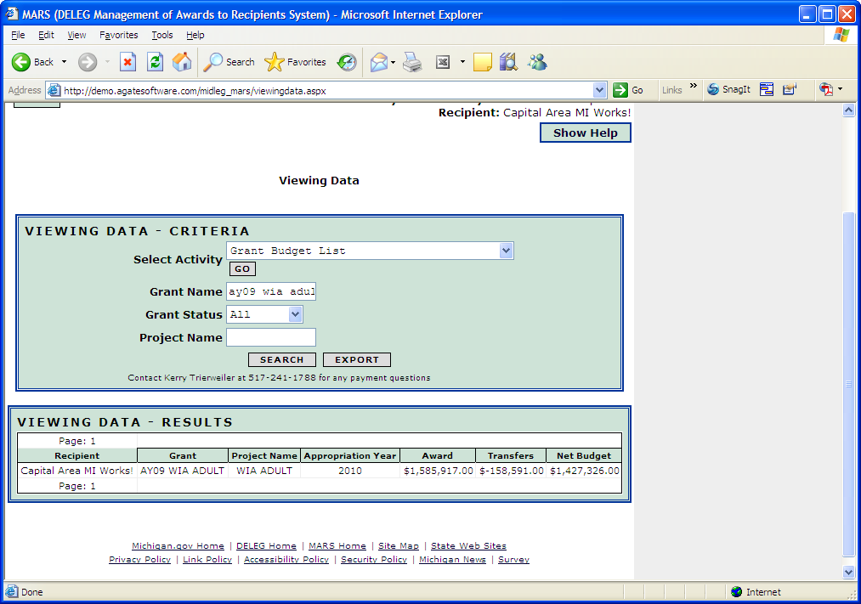

Project Draw and Balance
This query will show the grant name, project name, Project End Date, Award, Draws During Date Range (all draws YTD if date range is left blank), Cumulative Draws, and Balance Approved – Cumulative (Award less Draws).

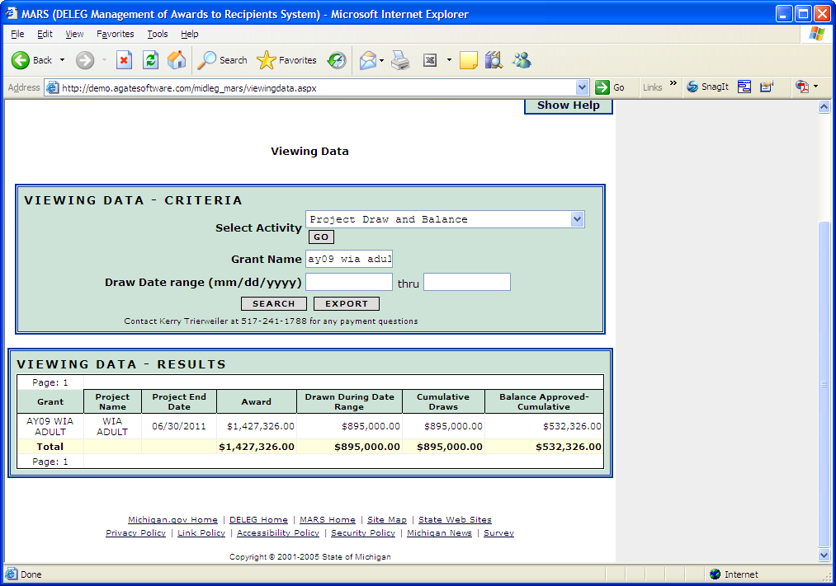

Projects
This query will provide information on all projects under a certain grant, or all grants and projects, depending upon the criteria entered.

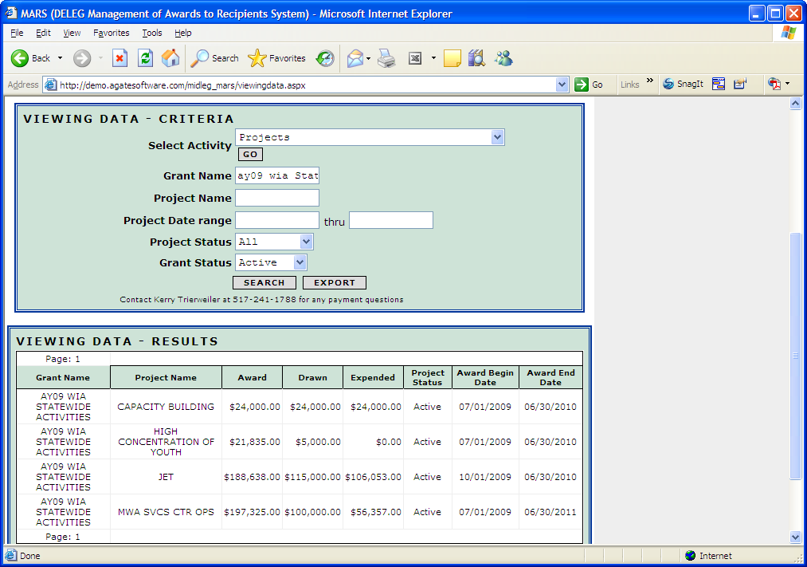

Recipient Identification
In the drop down box, select “Recipient Identification” and then click “Go”. After clicking go, click “Search”. The results will populate below in a separate box.
The Recipient Identification provides basic information about the recipient (name, address, county, MAIN mail code, FEIN, agency status, active, administrator name, email indicator)
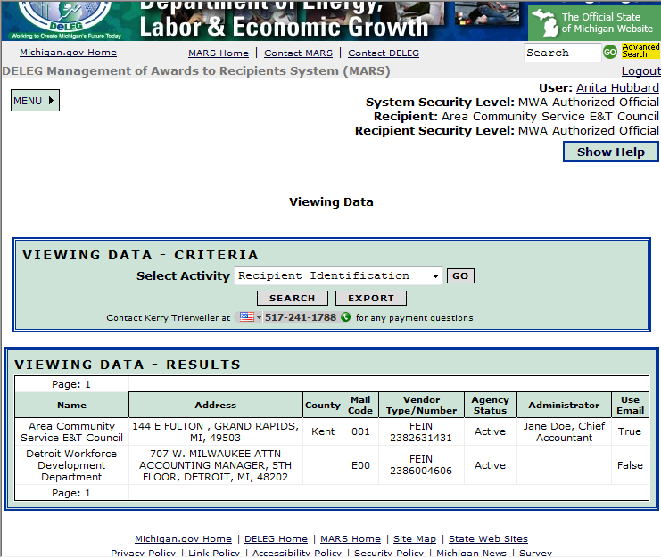
By clicking on the “Export” button, you can export the results from MARS into an Excel spreadsheet. After clicking the “Export” button a download file box will open. The user must either open the Excel spreadsheet from the web or save it to their computer. If the user opens the spreadsheet from the web, the file will open in a separate browser. If the user saves the file to the computer, they will be prompted to open the file once it has saved.

Users/Security Level
The Users/Security Level report lists all users that have access to the recipient. This includes user name, person’s name, any effective beginning and ending dates, if they are an email contact and if they are active.

For Assistance with MARS
Contact the following staff in the preferred order listed:
- Kerry Trierweiler
TrierweilerK@michigan.org
Phone: 517-241-1788
- Debra Lehmann
Lehmannd@michigan.org
Phone: 517-335-1046
- Lori Schomisch
Schomischl@michigan.org
Phone: 517-241-0672

